5th International Conference on Computing Communication and Cyber Security
(IC4S-05 Vol 1)
Date: 29/02/2024 and 01/03/2024

GENERAL TIPS FOR PARTICIPANTS
- 15 minutes before the session as per Presentation Schedule (2:00 PM): The host will start the Zoom recording.
- Registration and online joining through Zoom (1:00 PM): Participants need to join the meeting for registration process.
- Rename Zoom screen name: All participants are requested to change/rename their Zoom names as their Paper ID. If Paper ID is 101, then the Zoom screen name should be Paper ID 101. (See steps for renaming/changing Zoom screen name at the end of the document).
- Breakout Rooms in Zoom: The host will add participants in the breakout rooms in Zoom based on the final presentation schedule.
- Q&A for keynote speakers: Participants can raise hand in case of any question for the keynote speaker, then host/Co-host will unmute those participants for questions. (See steps for raising/lowering hand at the end of the document)
- Beginning of the presentation session: The session chair will announce the paper ID and the presenter will share its Zoom screen and start the presentation.
- Duration of a presentation: Each presenter will be given 10-12 minutes for presentation and next 2-3 minutes for Q&A.
DETAILED ZOOM GUIDE FOR PARTICIPANTS
Initial Zoom setup: Please install Zoom in advance.
How to join the session: Click the Zoom conference link that you have received via email with Zoom ID and password.
During the session:
- The session chair will mute all the participants except the presenter.
- Other members can either raise hand or write in chat for their queries.
After the presentation:
- Once the presenter done with the presentation, he/she has a choice to move out from the breakout room.
- There will be two options in the Zoom, i.e., Leave Meeting or Leave Breakout Room.
- The presenters are advised to select Leave Breakout Room, otherwise you will be exited from the IC4S-05 Vol 1 conference.
Steps to rename/change the Zoom screen name:
Step 1: Open Zoom and Log In with IC4S-05 Vol.1 registered mail ID.
Step 2: Select option “join with computer audio”.
Step 3: Click on “participants” at the bottom of the Zoom app and participant window will open
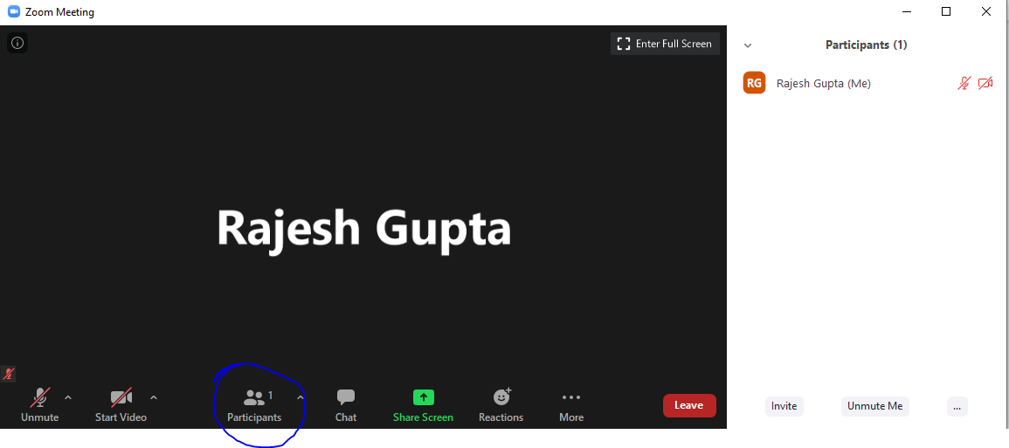
Step 4: Move pointer on to your name in the participant window and select “More --> Rename”
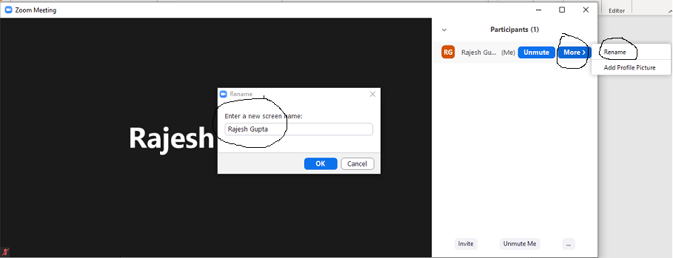
Step 5: Renaming of name is compulsory for all the authors of a paper. If more than one authors have contributed to a paper, then the naming conventions should be Paper ID 101_1, Paper ID 101_2, Paper ID 101_3, and so on.
Steps to raise/lower the hands for Q&A:
Step 1: Open Zoom and Log In with IC4S-05 Vol.1 registered mail ID.
Step 2: Select option “join with computer audio”.
Step 3: Click on “participants” at the bottom of the Zoom app and participant window will open
Step 4: Select the “…” and click “Raise Hand” and if the participant is done with the question then he/she need to click on “Lower Hand” option.
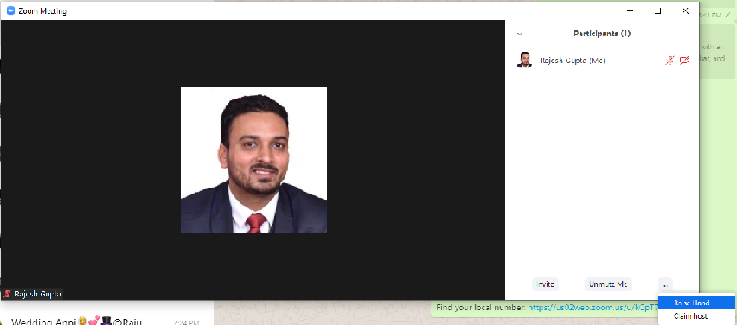

For any technical query (only related to Zoom), contact
+91-8866711305 (Mr. Nilesh Jadav)
or write email to ic4s2020@gmail.com

